Team Members
25000799 | 25000055 | 25001612 | 25001264
03
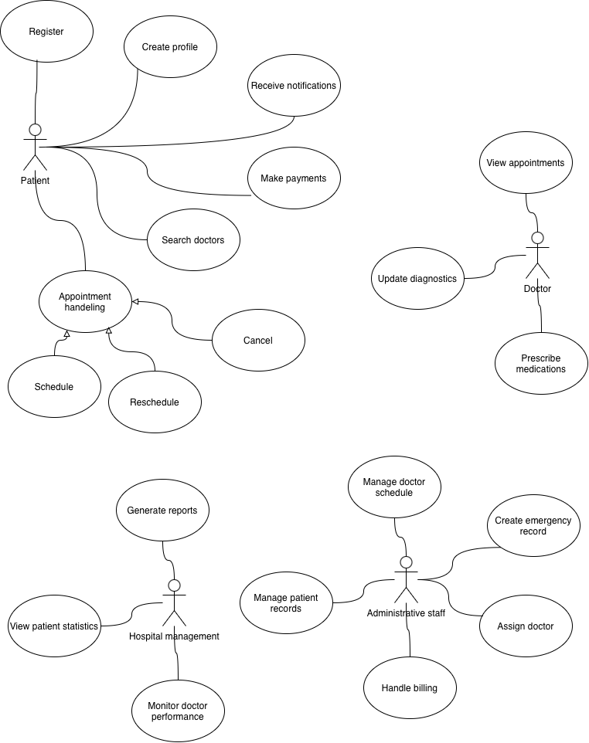
04
